|  |  |
| --- | --- |
| DJI Ryze Tello Powered by DJI  Model Based System Engineering  Study Year 2022 – 2023  S7 – Q1  Mini Drone | Fontys University – Electrical Engineering  Project group 7:  Vivian Cheung – 3911721  Indra Erkens – 3943836  Bart van Lent – 3886484  Wouter Mulder – 3786838  Stakeholders:  Fontys University of Applied Sciences  and MathLAB Simulink |

# Contribution list

Table 1 - List of contribution

|  |  |  |
| --- | --- | --- |
| **Name** | **Task** | **Date** |
| Vivian, Indra, Bart and Wouter | State Flow Onramp | 05-09-2022 |
| Vivian, Indra, Bart and Wouter | Get the simulation working | 06-09-2022 |
| Indra and Wouter | Adapt the simulation | 07-09-2022 |
| Vivian and Bart | Working on the report | 07-09-2022 |
| Vision system | Wouter | 5-9-2022 |

# Introduction

For this mini project, we must define a system for the mini drone. For the first part of the assignment, the system should contain enough complexity to understand this course. This means focusing on requirements elicitation and high-level system design, which will be shown in the following chapters.

To successfully approach and focus on the assignment for making a Parrot Drone working, we (fourth years students of Fontys University) are going to describe the model-based development cycle and the related activities we have done to successfully finish this course.

Also, the system requirements of the mini drone project are clearly defined to get the envisioned mini drone system partitioned into subsystems.

# Vision of the project

The vision for this project was done in Simulink. The camera of the drones sends its video to the computer via Bluetooth. With the vision, the project team would like to see if there is any blue in a picture. The project team has done this by making a vision algorithm. In the algorithm they take in the blue channel of the RGB image. That gets passed through a threshold to remove the parts of the image that are not blue enough. The image gets loaded into a custom MATLAB function that has a look at the binary image if there are white pixels visible. If so, the output of the function will be set to one. If there are no white pixels, the output will stay at zero.

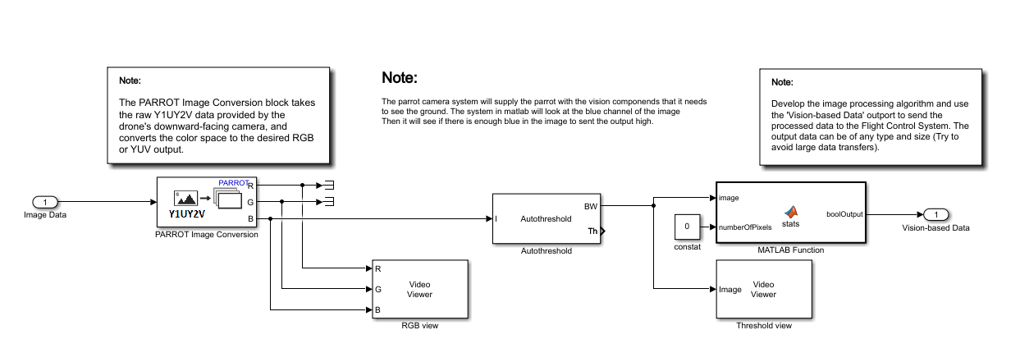

Figure 1 - Simulink vision

There are also two image monitors to monitor the output image of the drone. Also, to see if there is any blue in the image after the threshold block.

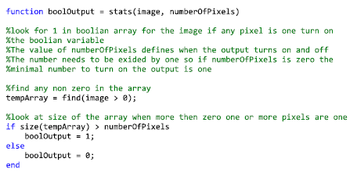

Figure 2 - Code of the simulation

The focus for this assignment is mainly on the simulation part. This is in an ideal environment. In the real world, there is no ideal environment, because the drone will see noise, false positives, and negatives. This must be removed by opening, closing and dilatation.

# Goal of the project

To complete the module MBSE (Model Based System Engineering) at Fontys Electrical Engineering in Eindhoven. Seventh semester students need to model base a system in MatLAB to control a Parrot drone to do certain activities.

This project group (project group 7) chose to let the Parrot drone fly a flightpath. Firstly, the drone needs to take off to an altitude of one meter. When the GPS of the Parrot drone recognize that the altitude of one meter is reached, the drone will fly straight forward. When the camera at the bottom of the drone recognizes the colour blue on the ground, the drone will stop flying forward and will start to fly straight to the right for one meter. If the one meter to the right is reached, the Parrot drone will stop going to the right and will climb to an altitude of two meters. When the GPS of the Parrot drone recognizes that the altitude of two meter is reached, the drone will fly one meter backwards. When it has reached its destination, the drone will safely land on the ground and the propellors will be turned off by itself. This path is done by making State Flows and functions.

The State Flows and functions of the simulation is shown in figure 3 below:

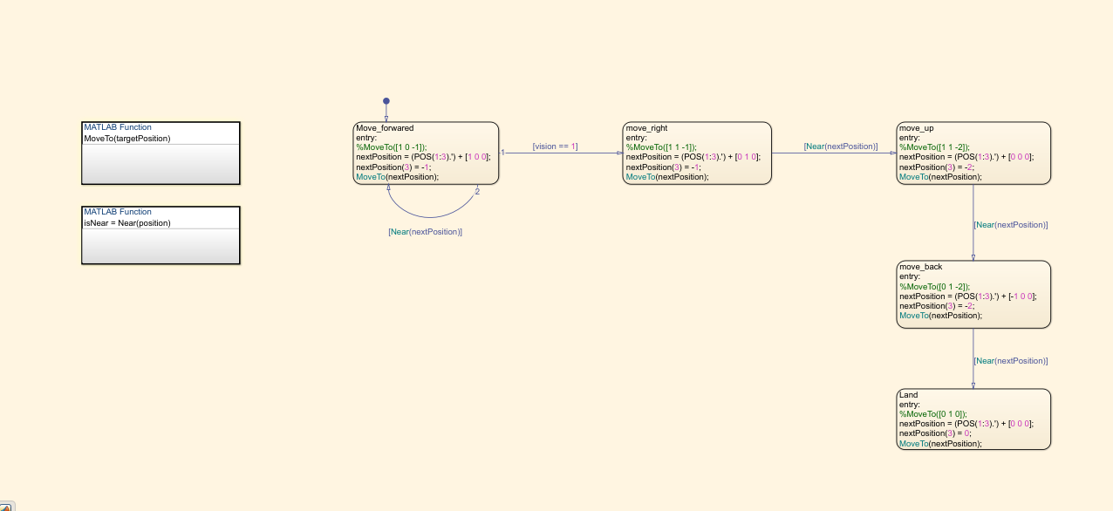

Figure 3 - State Flow and functions of the Parrot Drone

* Provide enough background knowledge to understand the assignment
* The requirements of the assignment are clearly described with an overview of their relationships.
* The top-level dynamic behavior of a designed system should be clearly described in SysML use case diagram.
* The structure of the developed architecture should be clearly described using SysML BDD and IBD diagrams. The IBD must be drawn in System composer and BDD can be generated as a view.
* 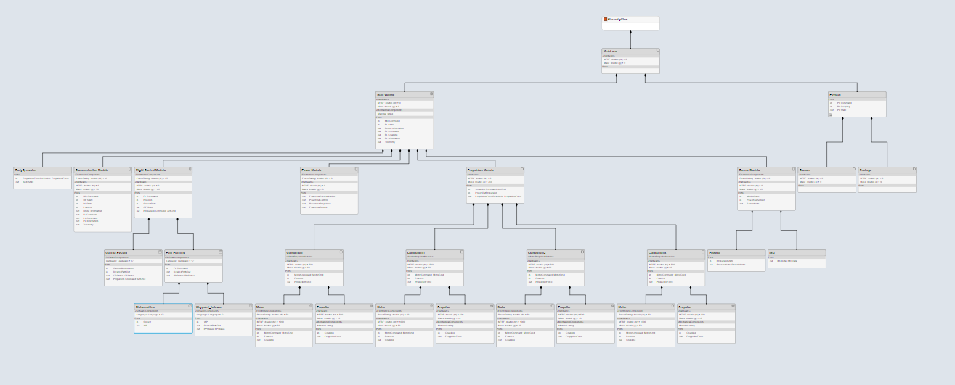
* The dynamic behaviour of a subsystem within the envisioned architecture should be clearly described in either SysML statechart diagrams or Simulink StateFlow diagrams.

# Overview of used software packages

To successfully get the Parrot drone working, the following software toolboxes are used in MatLAB Simulink:

Table 2 - Software toolboxes in MatLAB Simulink

|  |  |
| --- | --- |
| **Software** | **Image** |
| MatLAB Simulink:   * MathLAB Simulink Add-Ons: * Signal Processing toolbox * Aerospace Toolbox * Aerospace Blockset * ROS toolbox * UAV Toolbox * Simulink Control Design * Simulink Coder * Simulink 3D Animation * MatLAB Coder * Embedded Coder * Shared Transform Toolbox * Control System Toolbox * Image Processing Toolbox * Computer Vision Toolbox * MatLab for Parrot Drones Toolbox * Simulink for Parrot Mini Drones Toolbox | Basics of Matlab & Simulink. Matlab is a scientific tool ... |

* Consistency between BDD and IBD (or other diagrams)

Technical details:

|  |
| --- |
| There is a well thought out and clearly described system architecture. (Is there technical substantiation and / or motivation). |
| Are the stakeholders of the system clearly identified and their interaction with system considered? |
| Did the team use functional decomposition to understand the requirements and to decompose the system into subsystems? |
| The team understand the correct use of Use Cases |
| The verification and validation of the developed architecture is considered. Some parts are already tested. |

# Conclusions and recommendations

# Reference list

# Certificates

Vivian Cheung – 3911721

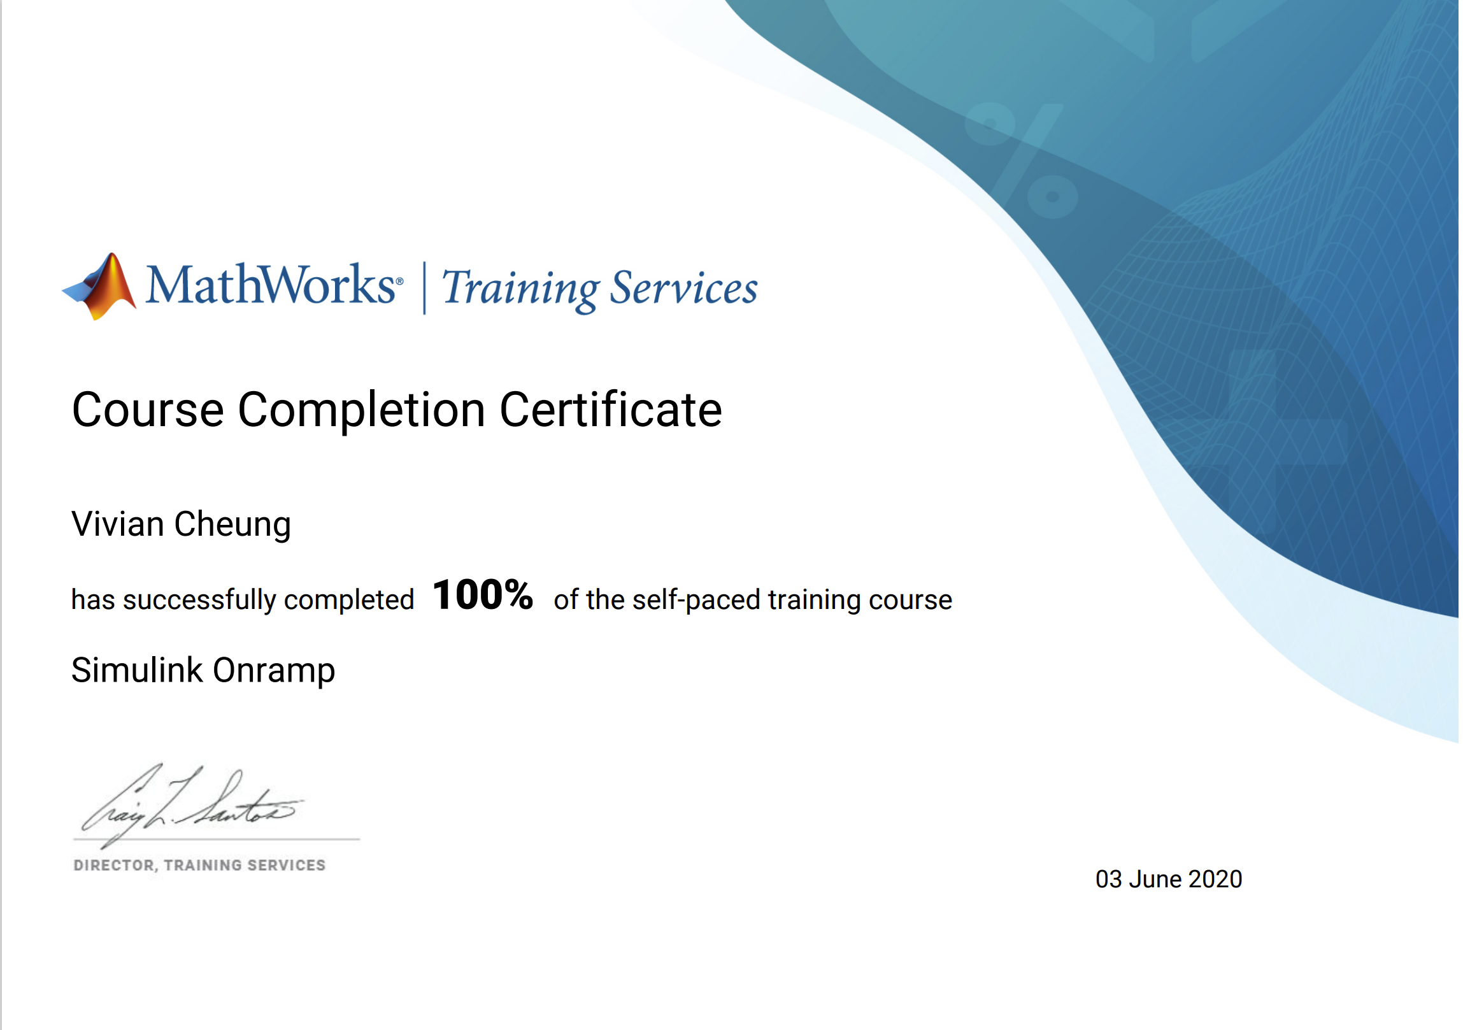

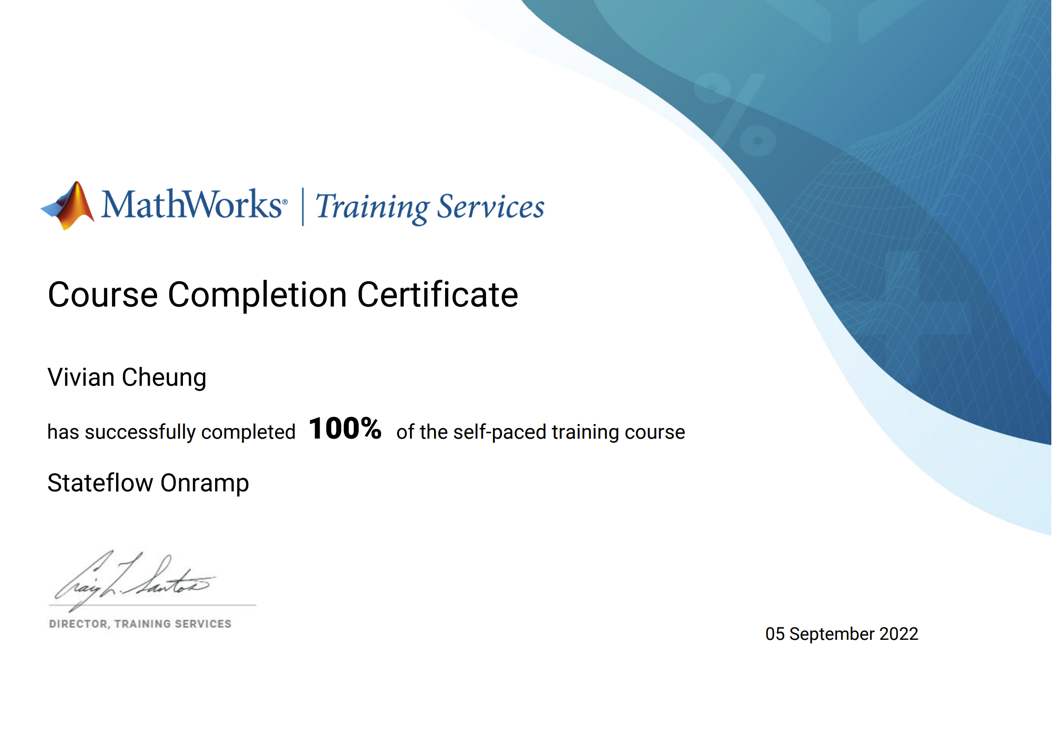

Indra Erkens – 3943836





Bart van Lent – 3886484

Wouter Mulder – 3786838

